You are starving and you want to eat food as quickly as possible. You want to find the shortest path to arrive at any food cell.

You are given an m x n character matrix, grid, of these different types of cells:

* '*' is your location. There is **exactly one** '*' cell.
* '#' is a food cell. There may be **multiple** food cells.
* 'O' is free space, and you can travel through these cells.
* 'X' is an obstacle, and you cannot travel through these cells.

You can travel to any adjacent cell north, east, south, or west of your current location if there is not an obstacle.

Return *the* ***length*** *of the shortest path for you to reach* ***any*** *food cell*. If there is no path for you to reach food, return -1.

**Example 1:**

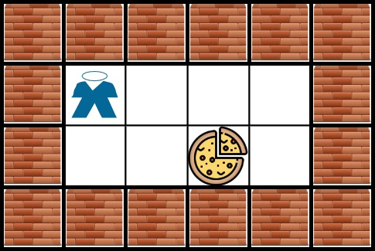

Input: grid = [["X","X","X","X","X","X"],["X","*","O","O","O","X"],["X","O","O","#","O","X"],["X","X","X","X","X","X"]]  
Output: 3  
Explanation: It takes 3 steps to reach the food.

**Example 2:**

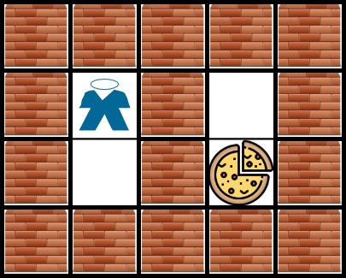

Input: grid = [["X","X","X","X","X"],["X","*","X","O","X"],["X","O","X","#","X"],["X","X","X","X","X"]]  
Output: -1  
Explanation: It is not possible to reach the food.

**Example 3:**

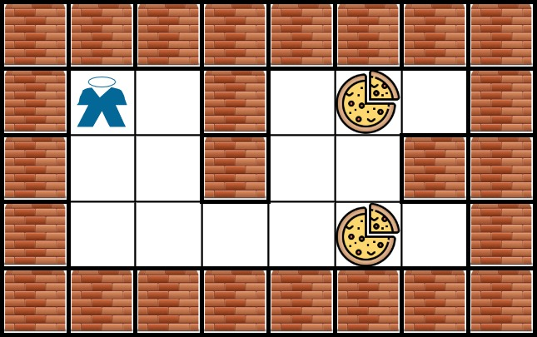

Input: grid = [["X","X","X","X","X","X","X","X"],["X","*","O","X","O","#","O","X"],["X","O","O","X","O","O","X","X"],["X","O","O","O","O","#","O","X"],["X","X","X","X","X","X","X","X"]]  
Output: 6  
Explanation: There can be multiple food cells. It only takes 6 steps to reach the bottom food.

**Constraints:**

* m == grid.length
* n == grid[i].length
* 1 <= m, n <= 200
* grid[row][col] is '*', 'X', 'O', or '#'.
* The grid contains **exactly one** '*'.